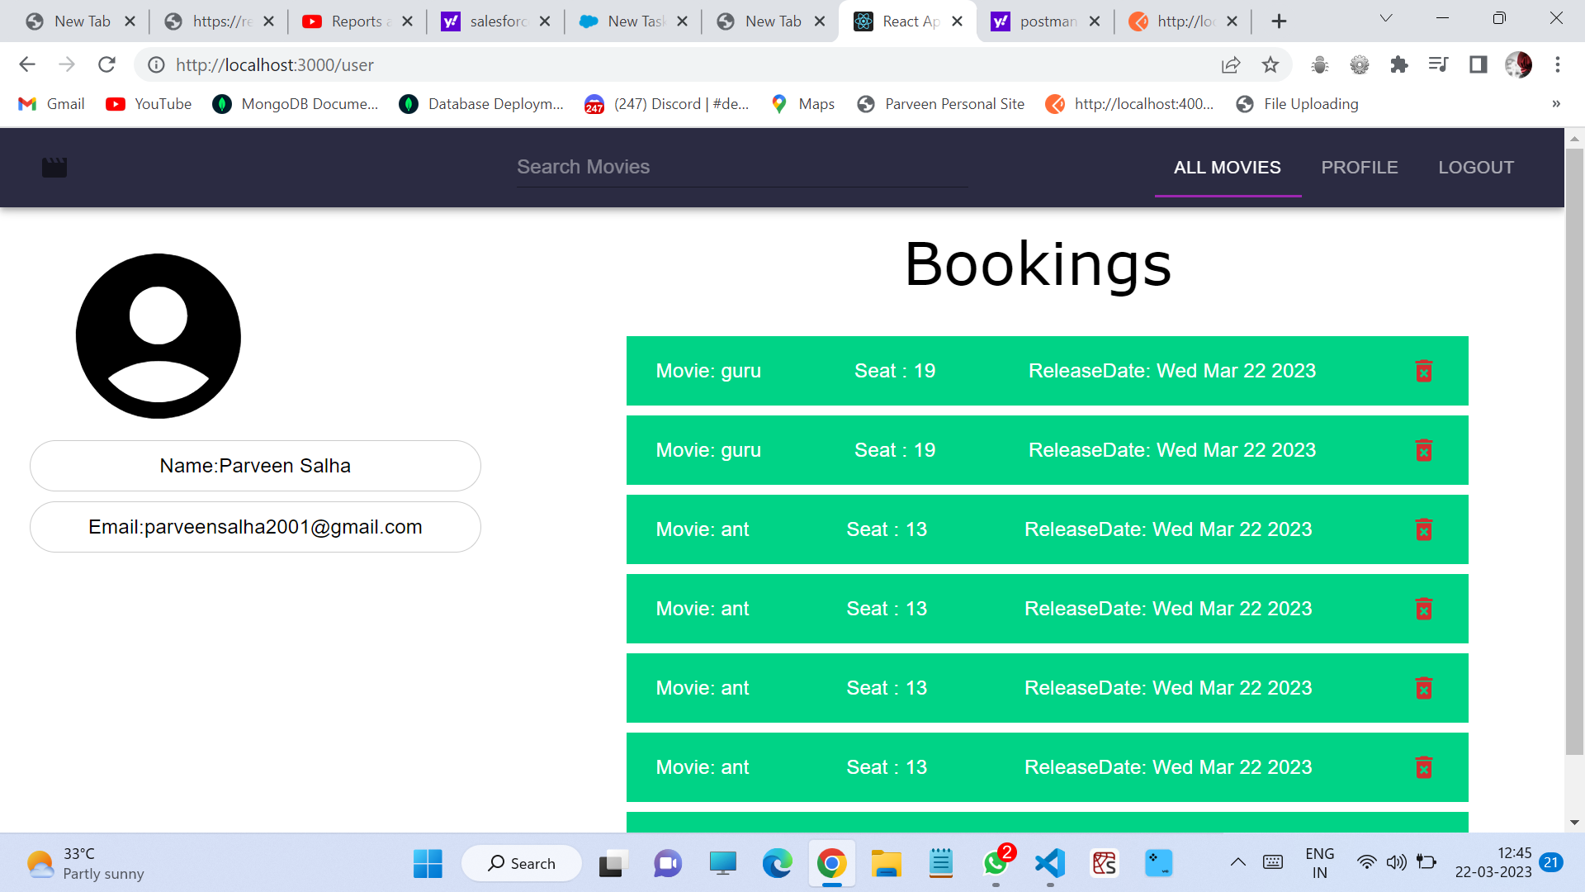

For displaying Bookings page move to postman

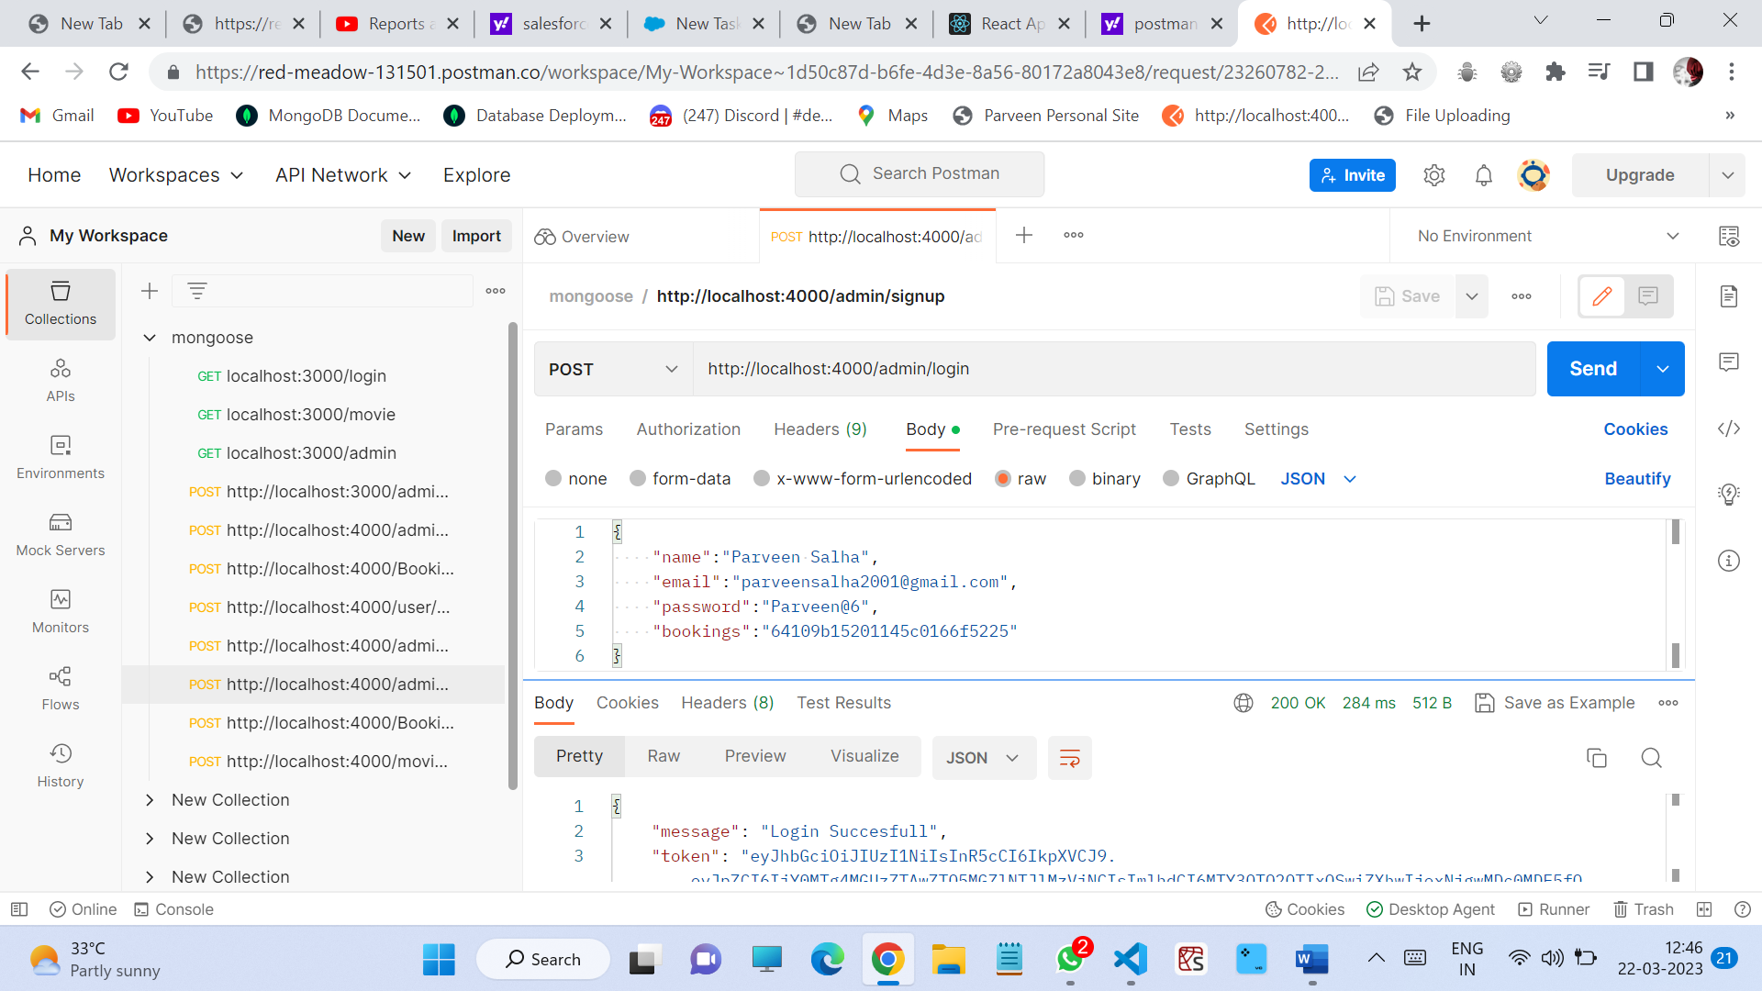

Give send and a token will be generated

Then move to react website

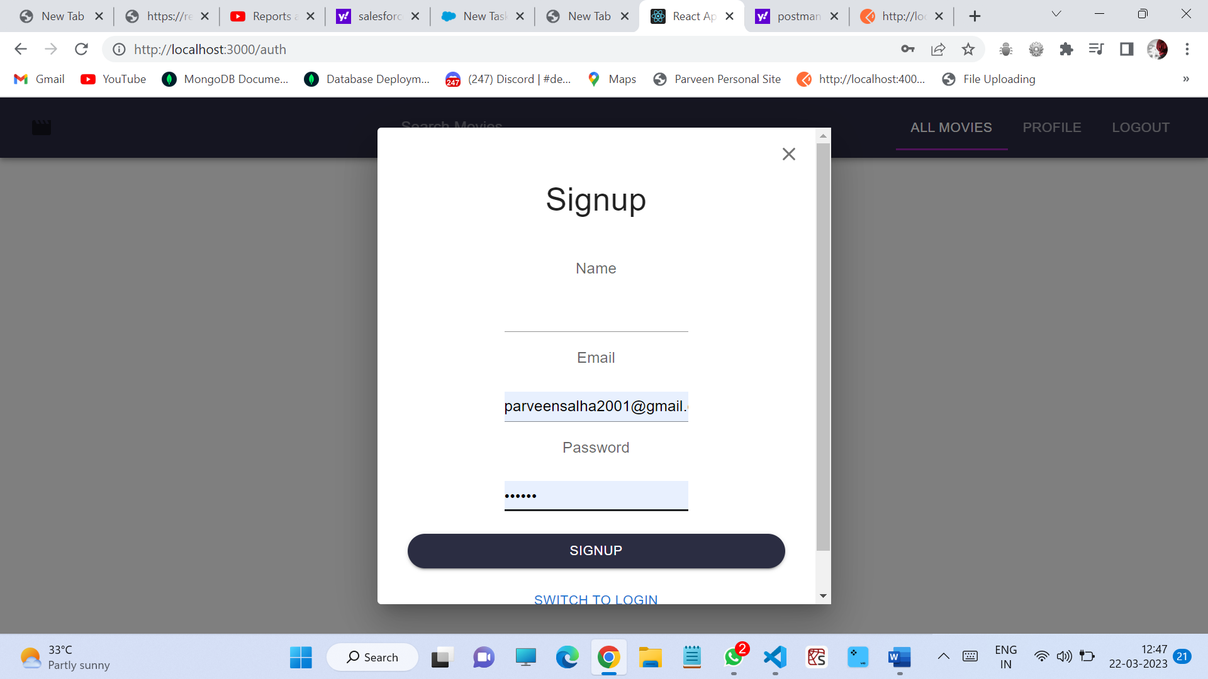

Give name , email and id then u can select all movies

And move to

http:localhost:3000/users

http:localhost:3000/admin

http:localhost:3000/user-admin

